3d model of the school

Cyril and Methodius Church elementary school
Lerchova 65, Brno

Contents:
Introduction 3
Annotation 3
Objectives 3
Technique used 3
Organisation 3
Methodology, procedures 4
Modelling in Sketchup 4
Roof construction on the resulting floor plan 5
Facade profile solutions – cornices, irregularities, attics, manholes (push/pull) 6
Printing a school model in a 3D printer/school prototype 7
Method 7
Photo: 8
Target model of the school 10
Method 10
Photo 12
3D printer problems 15
Photo 15
Conclusion and contribution of the project 17

Introduction

Annotation
The basis of the project is for the students to become familiar with new digital technology, such as working with a 3D printer. Furthermore, the possibility to work in graphic programs for 3D modelling of the object. Which should lead to the strengthening of digital literacy and will support their development of IT thinking. Pupils also work together in teams and collaborate on assigned goals. They become familiar with technology and new programs and their functionalities. They verify various work procedures, create sub-products and consult the creation with the manager. They solve the problems that arise on the way to the goal, propose different solutions, carry out a procedure and evaluate the success of the progress to the goal.

Objectives
Create a 3D model of the school in the most plausible form possible, in the chosen graphics program.
Print this model in a 3D printer.

Technique used
3D printer - type Reality CR-10 V2 (filaments and tools for editing 3D printing).
Graphics programs used: Cura Ultimaker, Sketchup

Organisation
The project was implemented in the subject Informatics and the World of Work. for selected pupils from the eighth and ninth grades. The students were divided into two groups. The first group worked in a graphics program and created the first shapes of the target object. The second group got to know the 3D printer and printed the first shapes of the building.

Methodology, procedures

Modelling in Sketchup
Our project begins with an introduction to the architectural software Sketchup, which we have chosen as a freely available program in which pupils can work even at home in the time of covid. The advantage of this program is that, apart from the fact that it is free to download, it is easy to use. Even us, the lecturers, who had no experience with this software before, had to learn how to use it. It was very time-consuming to create a model that is printable for the printer. It was necessary to become familiar with the thicknesses of the walls, their adhesion to each other, and it was necessary to constantly check whether the individual parts were only apparently glued together. A common mistake verified by endless hours of test prints was a mistake in the perception of dimension. An unpleasant feature of the Cura Ultimaker and Sketchup programs is their inability to preview from all angles. This fact caused many model fitting errors.
During distance learning, students were given the task of getting to know Sketchup at home. When we had the chance, we discussed our experiences face-to-face at one computer. We created the final project after many hours of joint modelling under the guidance of lecturers. Sketchup's basic tool is extrude/extrude, which is illustrated in the image below.

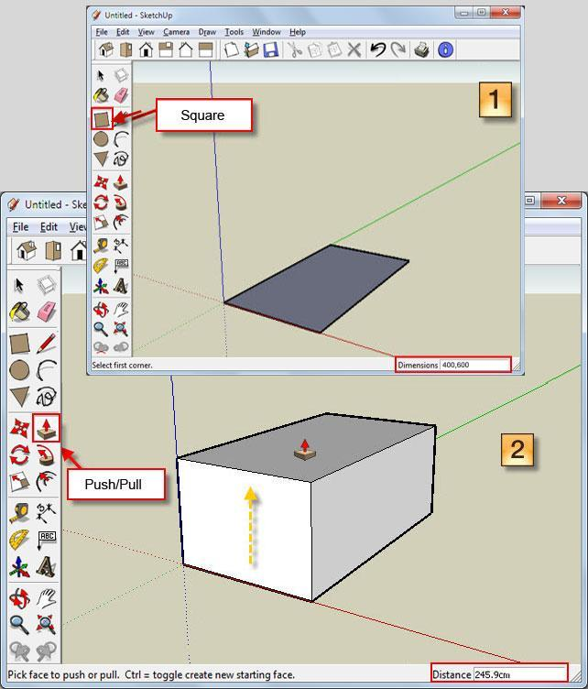

Use the rectangle tool to draw a floor plan on the surface, between the x and y axes. It is then pulled to the z axis using the "push/pull" tool. We constructed the roof using the "pen" tool, which draws lines along the vertical axis into the space. When the segments are connected in a certain shape, these lines are closed and it is possible to further pull the slopes of the roof into the space with the help of the "push/pull" function. Using the copy and paste function, we copied the windows according to the actual ratios and proportions and pushed them into the depth of the wall. In the same way, window frames (window profile) are also created by the extrude function. From a chronological point of view, we proceeded as follows:
The basis of the work is the floor plan of the building in the shape of the letter C and drawing it into the space (pen and rectangle tool)
The slope of the terrain was not taken into account in this project.

Roof construction on the resulting floor plan

We construct the roof using the pen tool towards the air along the blue axis and create a triangle. Using the push/pull tool, we stretch it along the entire length of the right wing of the school (as seen from the playground) and stop at the point where the entire school ends. From the left side of the facade, we will again draw a triangle shape and using the push/pull tool, we will stretch the roof over the entire front block, intersecting/overlapping the part of the roof that we constructed first, blending it into itself.
Then we outline with the pen tool the individual edges of the contact, where the two roofs sink into each other. This will give us a new custom shape. Then we still have to look inside the roof with the camera and use the eraser tool to delete the protruding part of the first roof inside. We constructed the last left wing from back to front, while at the front it again blended with the front seat of the roof. Adjusted the back bevel using the bevel tool. In cases where the bevel tool cannot be used, or it is too difficult, it is possible to bevel objects by cutting through another bevelled object.
Using the pen tool, we drew the dormer in the air along the blue axis and stretched it through the roof and from the inside, around traced with a pen and deleted again from the inside.

Facade profile solutions – cornices, irregularities, attics, manholes (push/pull)

We solved the ratio between floor windows and cornices by estimation and by sketching all cornice windows on top of each other in one column from one side and comparing according to the photo. The windows are of course profiled, so we achieved the desired shape with the help of punching, including the window frames. After marking the line segments of the entire window, right-click and select the group function. This is so that the lines stick together when you move them. And with the help of copy/paste and according to the photo, we will place them at the correct intervals throughout the floor.
The cornice is modelled into the space using the pen tool and is stretched along the entire length of the facade. In places where it turns to a right angle, two different ledges sink into each other in the same way as roofs.

Time consumption: for a complete beginner, as in our case, the time consumption was immeasurable, because it involved learning the program by trial and error and according to tutorials. In a professional case without making mistakes, the model could be finished in 8 hours

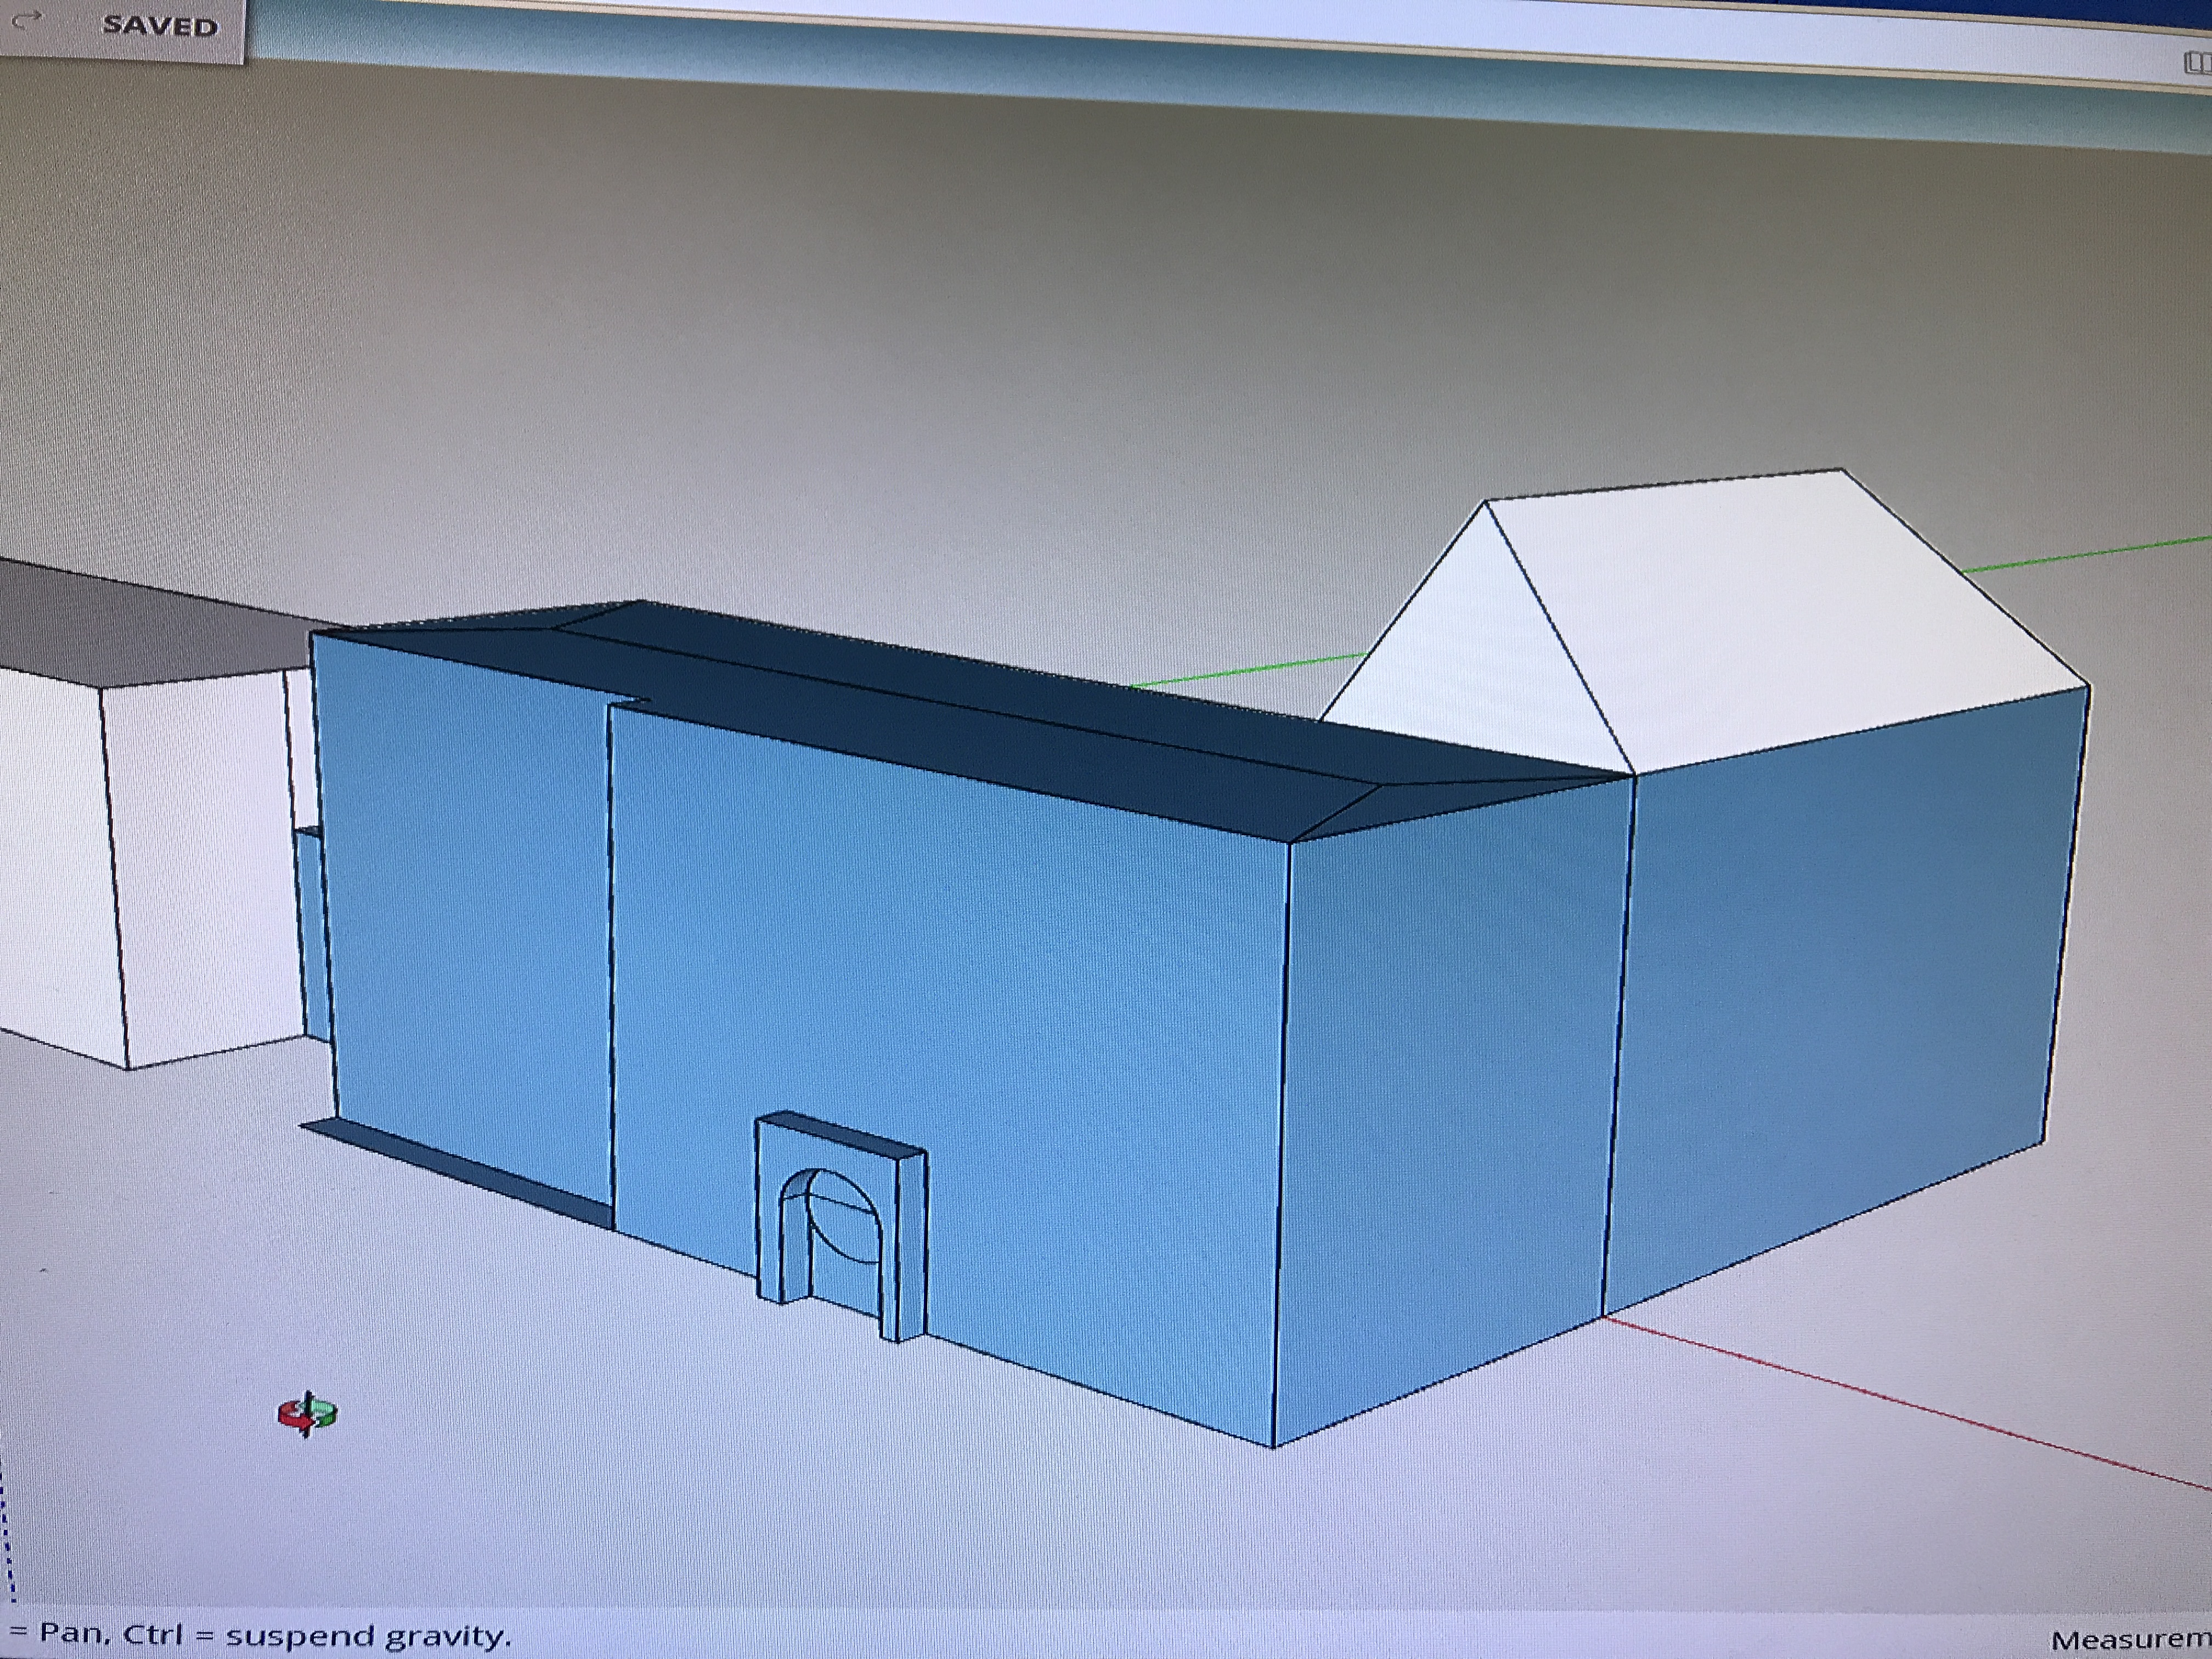
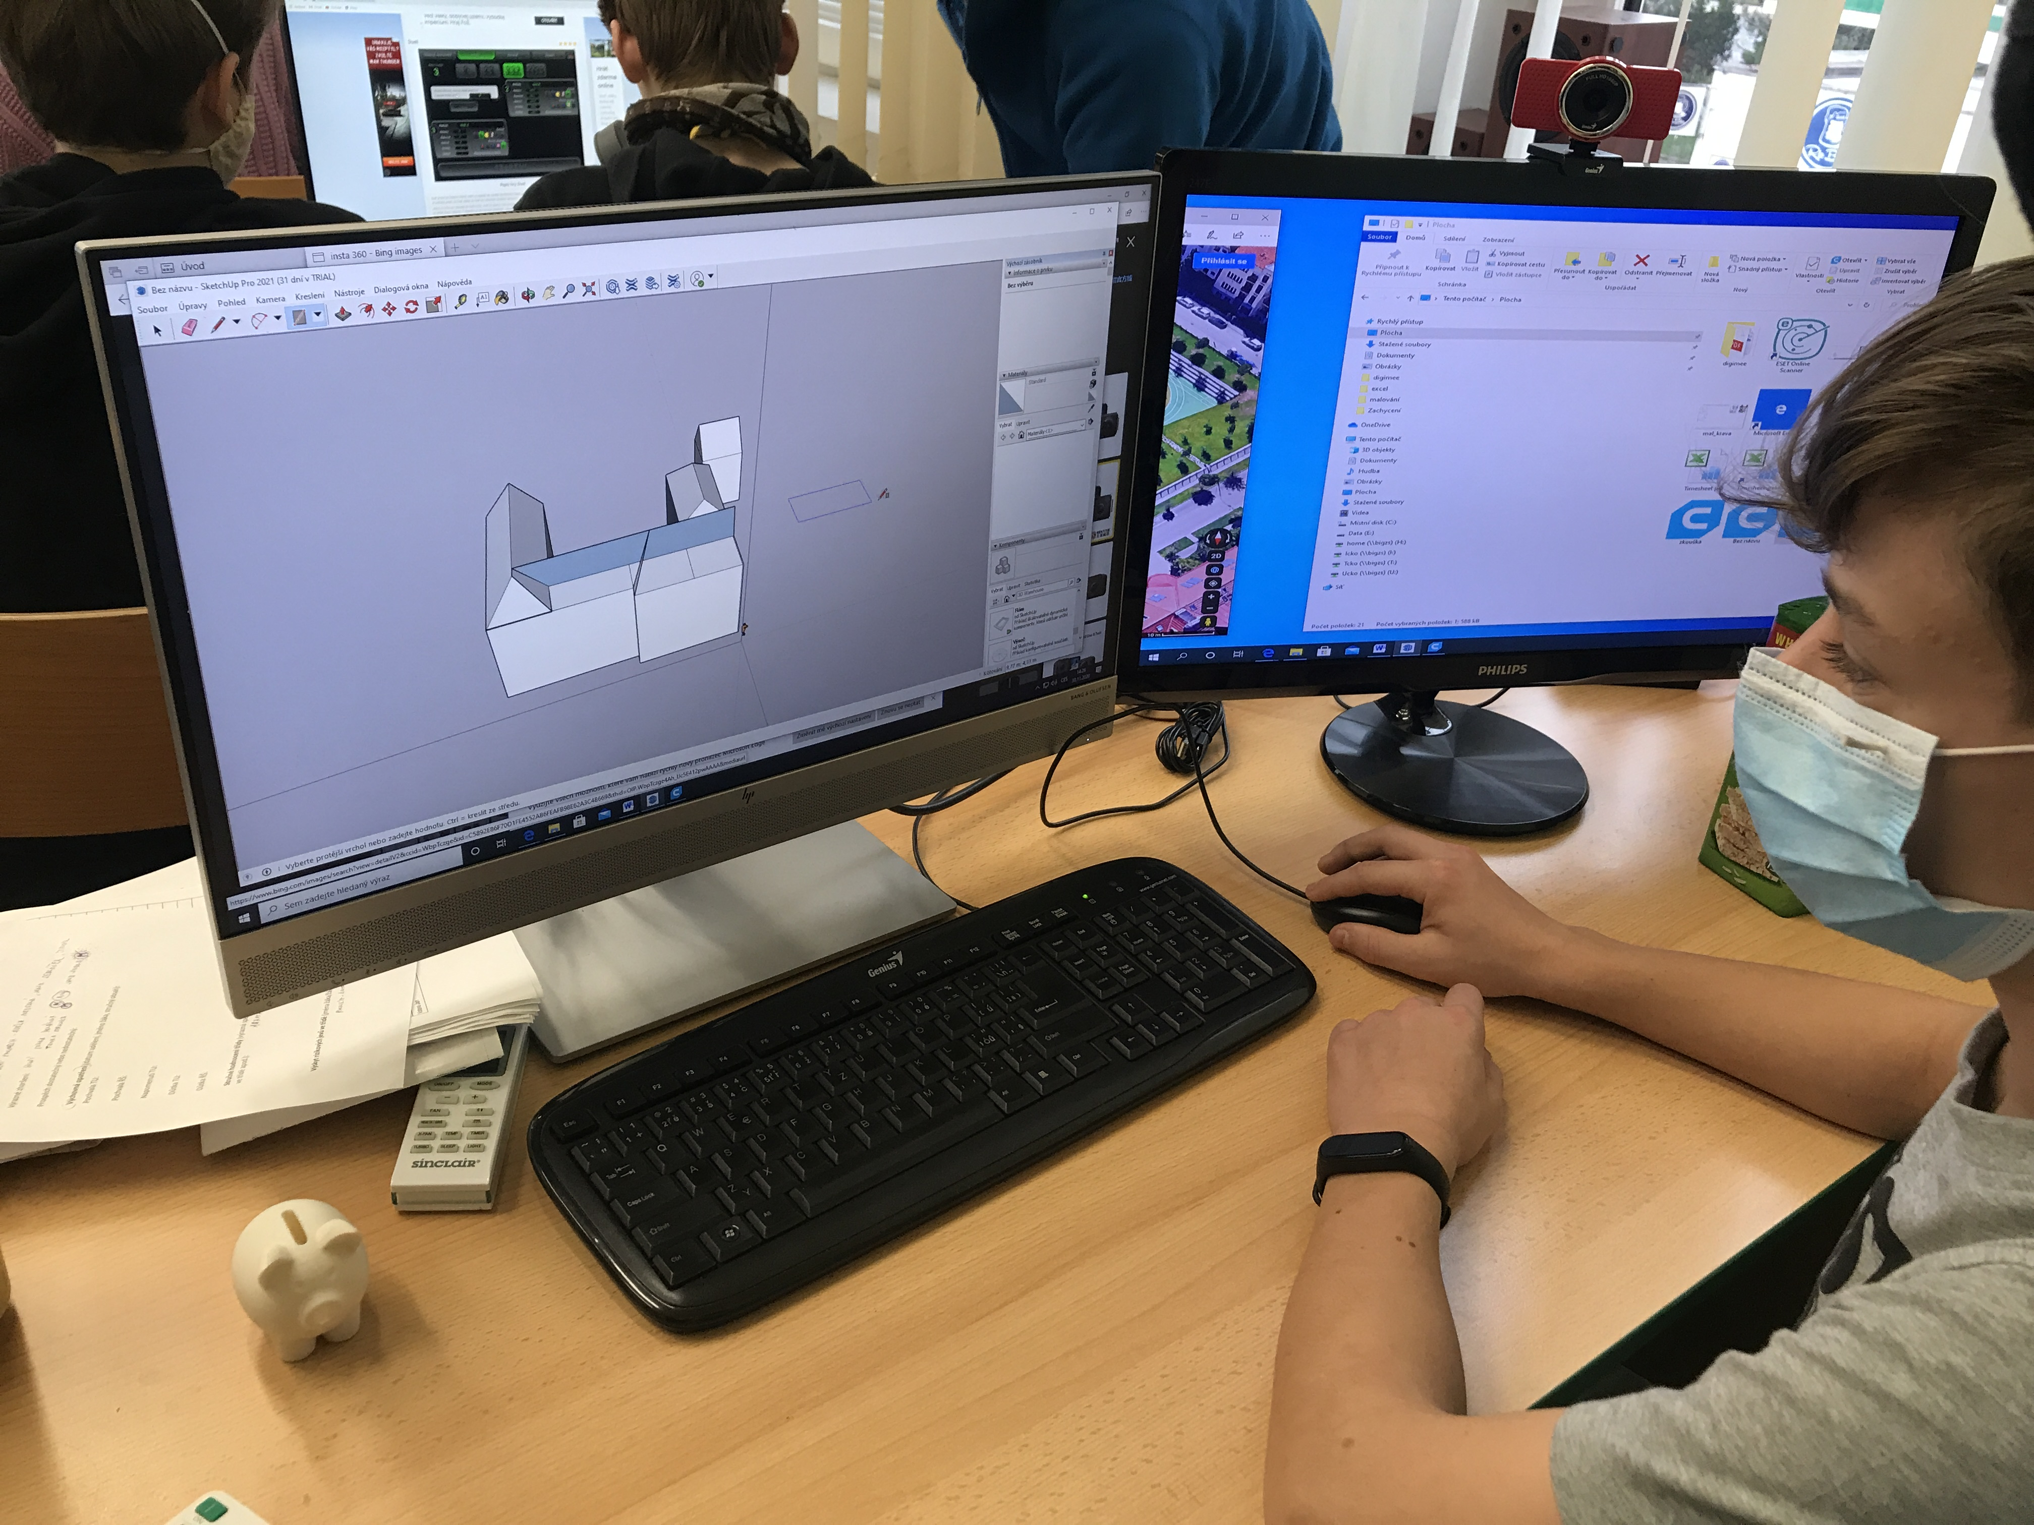

Printing a school model in a 3D printer/school prototype
The student came up with the idea that we could print the created model in 3D printing first in a small version. Gradually print all floors separately and also the roof. We wanted to test whether the printing would be successful or if there would be complications. Under the supervision of the teachers, the students created the individual floors of the model and set the parameters for printing in the Ulitamaker Cura program.

Method
In the sketchup program, we used the "blade" tool to divide the model into individual floors and the roof.
Then we opened the file in Ultimaker Cura and set the parameters for 3D printing.
In the print settings, we decided to print the model with perimeter walls without internal filling, so we set the filling density to 0 %.
To leave all the architectural elements of the model, we chose to generate support in the settings.
We also chose the size of the individual floors. Since I wanted to test the first print of the model, the 65 % size was enough for us.
Then we matched the object and set the individual layers of the object for printing.
We saved the file to the SD card adapter named “1. floor" with the suffix code. The file converted in this way can already be used for 3D printing needs.
We inserted the SD card into the 3D printer and selected the Print from TF item in the menu.
We selected the appropriate file from the SD card and set other parameters to achieve the best possible results when printing. We set the print speed to 110 °C and the nozzle temperature to 205 °C, the substrate temperature to 60 °C.
After printing each floor, we removed the support using pliers and a spatula. We glued the individual floors together with the roof and created a school prototype.
Time required: 4-5 hours
Note:
We do not need to set the parameter for printing for each floor separately. In the print settings, you can create a profile with the required parameters in advance. That way, we don't have to mechanically repeat individual parameter settings.

Photo:
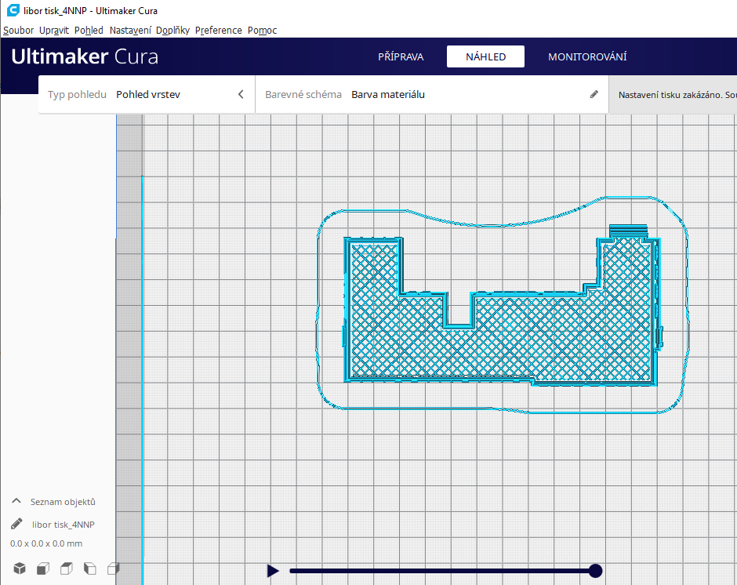
Example of the fourth floor in the picture.

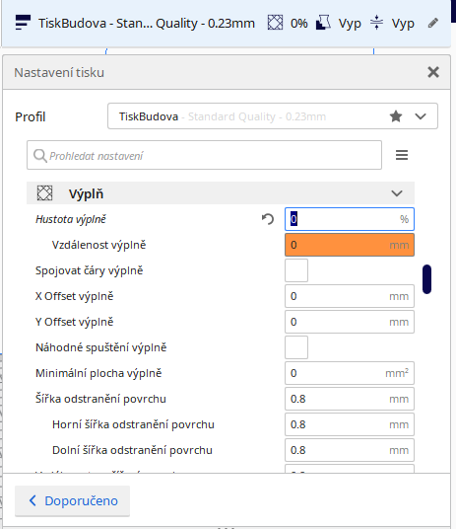

- Filler panel (density of filler)

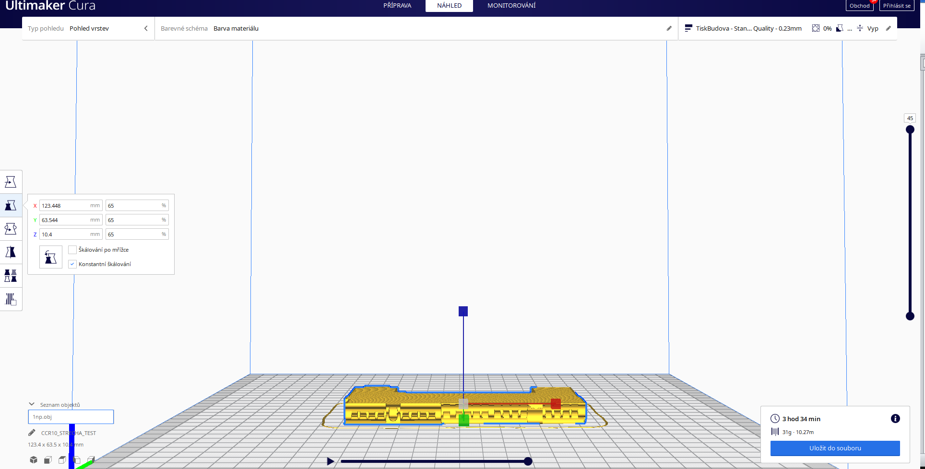
Sample – setting the floor size in Cura Ultimaker
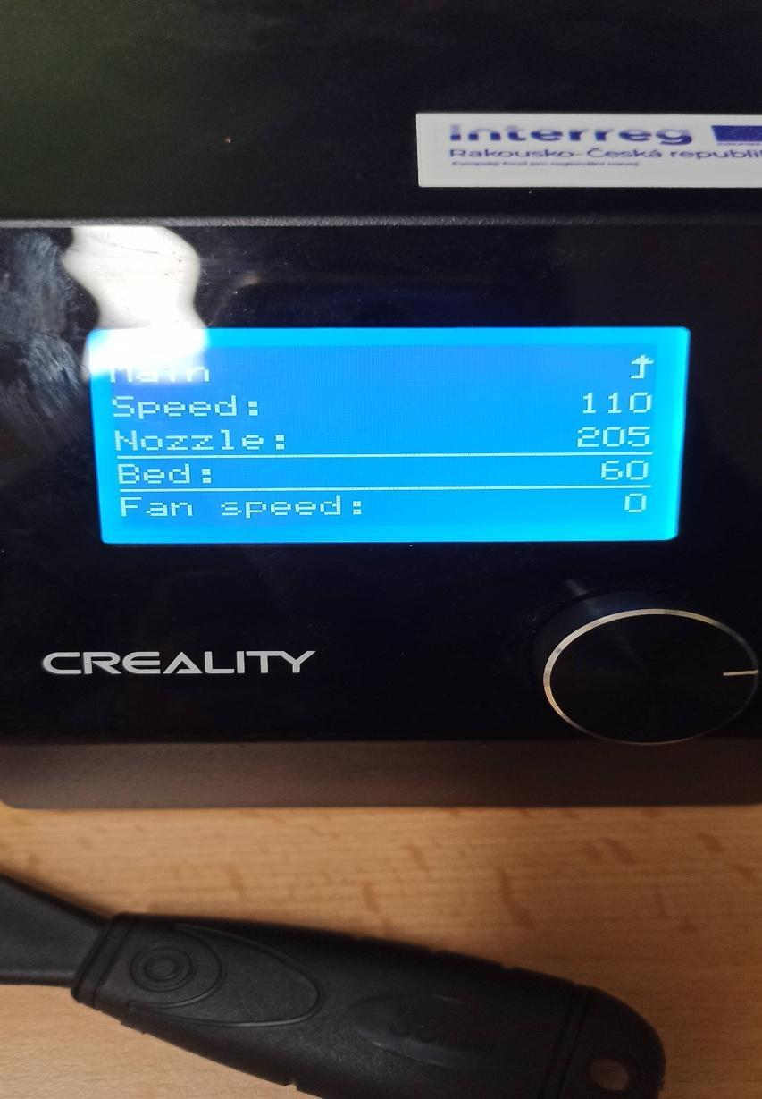
Setting up the 3D printer before printing the scale model

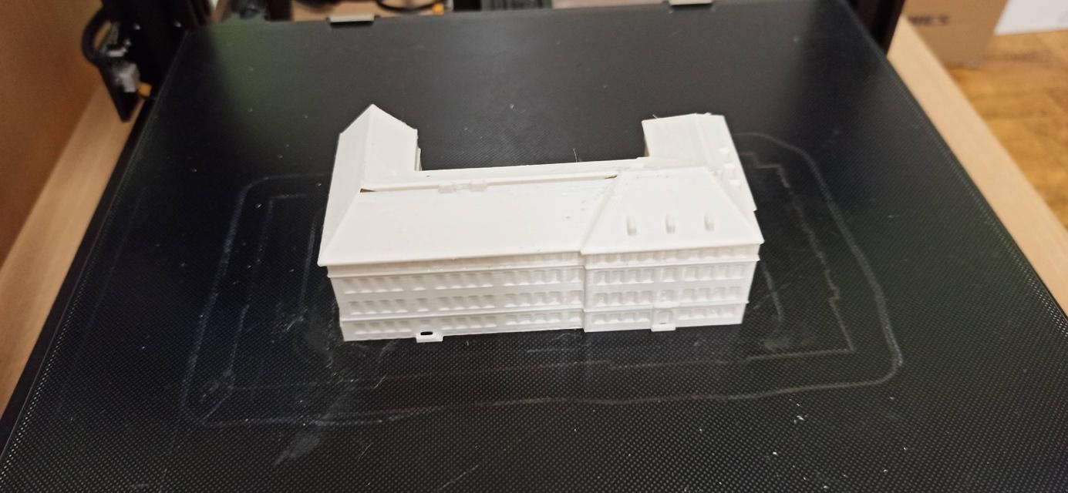
Glued model of the school prototype

Target model of the school

The printed prototype of the school showed us that the model of the school, created in the sketchup program, was successful. The students agreed that they want to print the model of the school for the final competition in the largest possible size.
We enlarged the object more than twice in the sketchup program.
We also knew that the model had to be in our chosen size, divided into at least 3 parts, in order for the building print to fit on the mat.
After the experience of the previous attempts at printing the building, it was clear that we would have to choose at least some internal filling of the building that would help us to print the model in a larger size and not have printing problems.

Method
In the sketchup program, we stacked the individual floors with the roof into a complete building. The size of the 3D printer pad was too small to print the entire object, so we divided the object into 3 parts.
The procedure is as follows:
We will create an object that has no depth, it is only a drawn square that is not stretched. Draw a square around the cut part of the building. Then we mark the building and the square and choose the subtract function. Then we move the two parts apart and clean the remaining line segments with the eraser tool so that the block is uniform without unfinished lines.
We saved each part as one file for printing.
We then opened each part of the building in Ultimaker Cura and set the print parameters.
We printed the building without generating support and this time we set the fill density to 20%. Then we enlarged the object to 150 % in all three axes x, y, z, i.e. more than twice.
We then saved the file on an SD card and inserted it into the 3D printer.
We selected the Print from the TF item in the menu. Then we printed all 3 parts in turn.
We selected the appropriate file from the SD card and set up next parameters to achieve the best possible results when printing. We set the print speed to 110 °C and the nozzle temperature to 205 °C, the substrate temperature to 60 °C.
In the next step, we used a spatula to peel off all 3 parts from the mat.
We connected all three parts with glue and started painting the school roof red.
Time required: 3 hours of work in sketchup, 12 hours of printing one part, a total of 36 hours of printing all 3 parts.

Photo
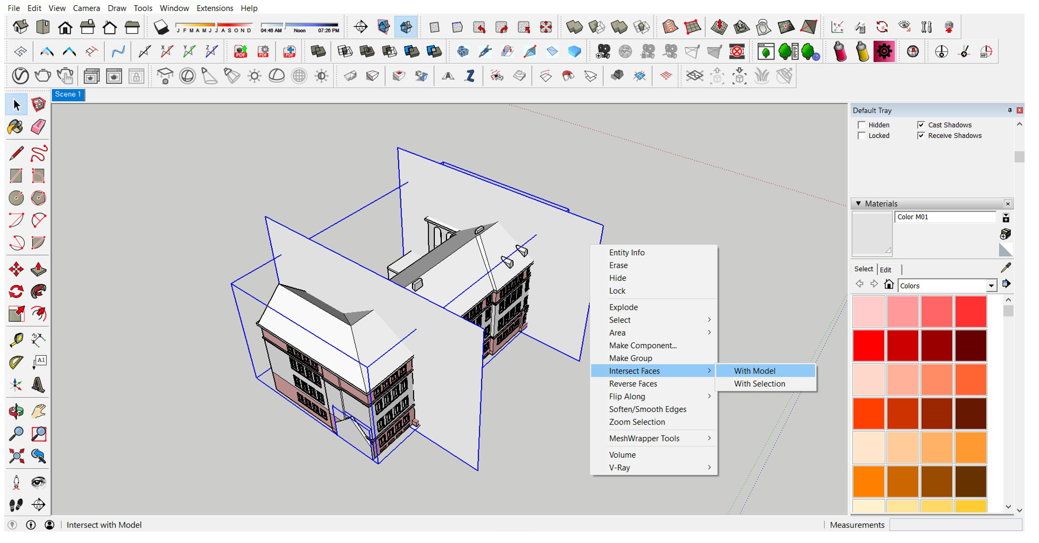
Division of the building in the sketchup program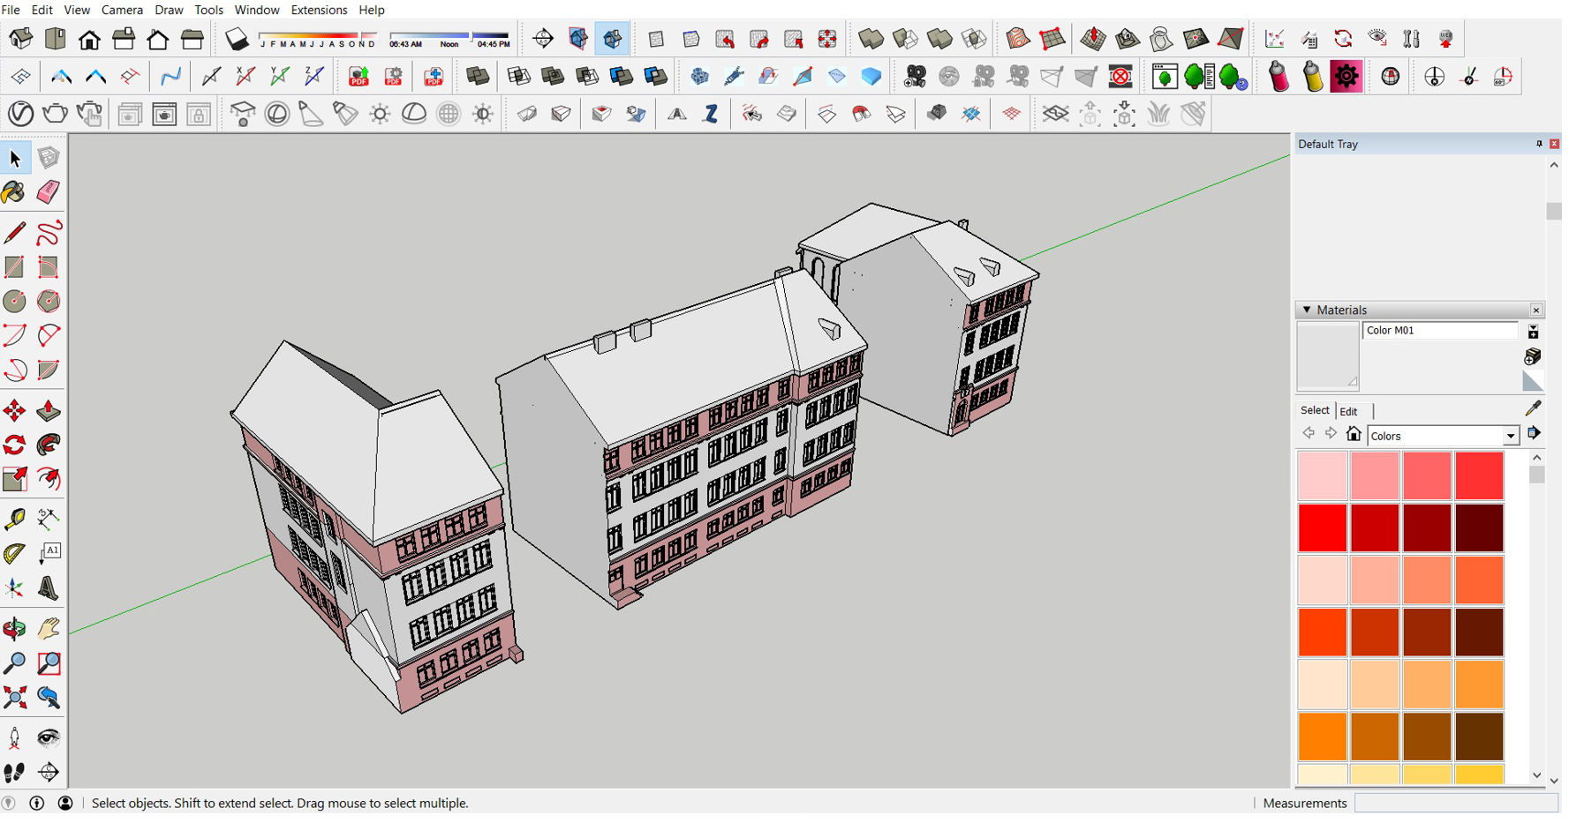

Result
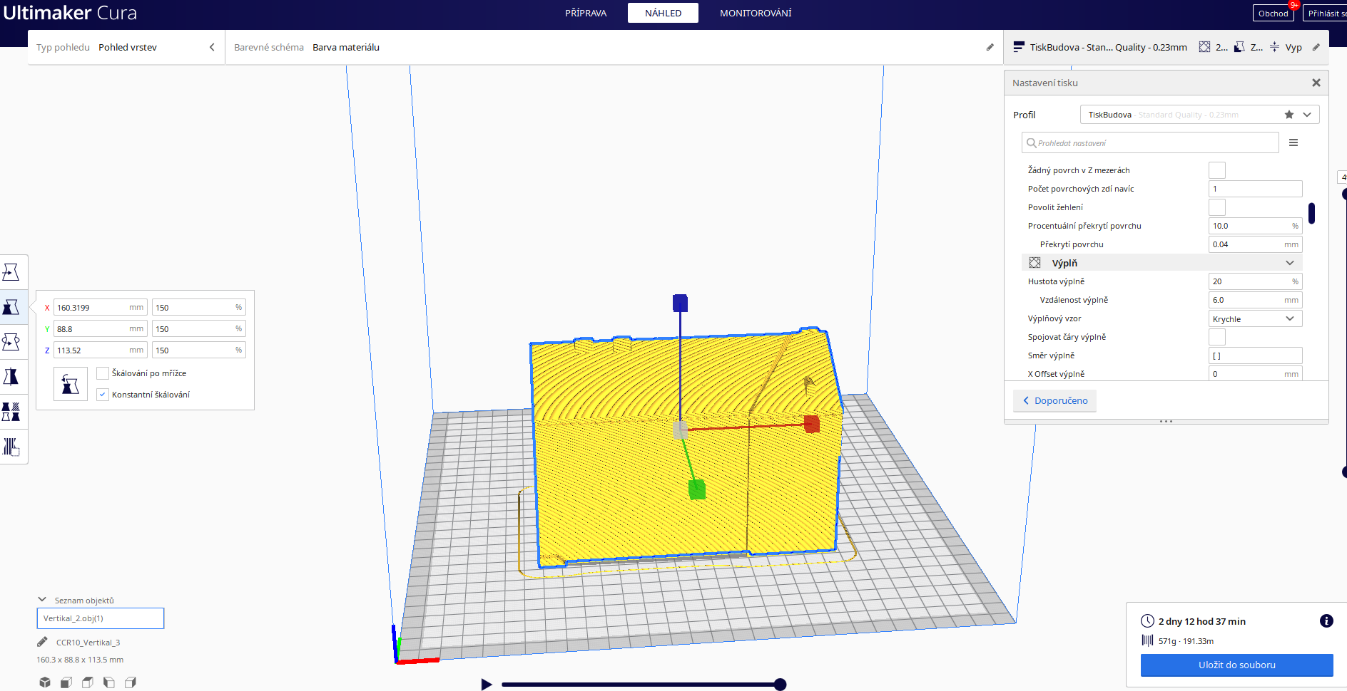
Configuring and merging one part in Ultimaker Cura

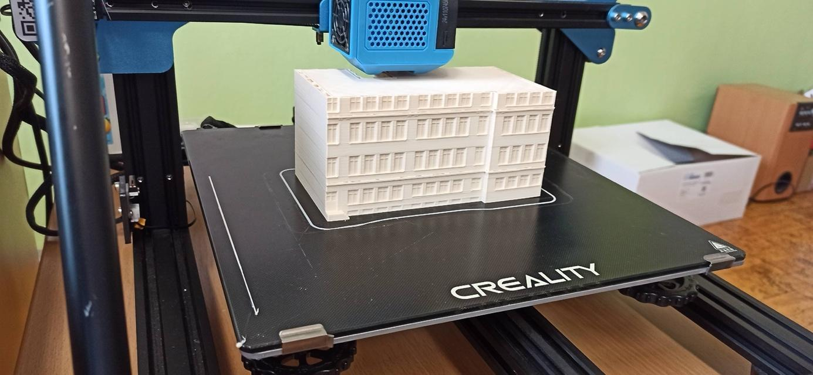

Print the middle part of the building
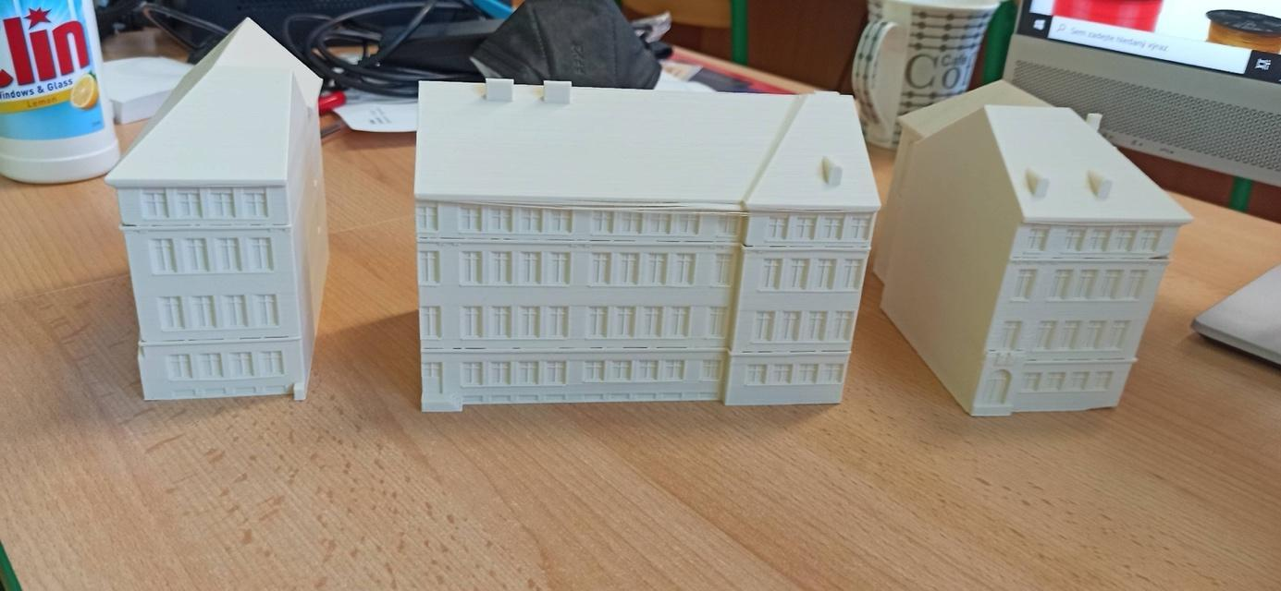
In the next step, we already connected all three parts with glue and started colouring the school.

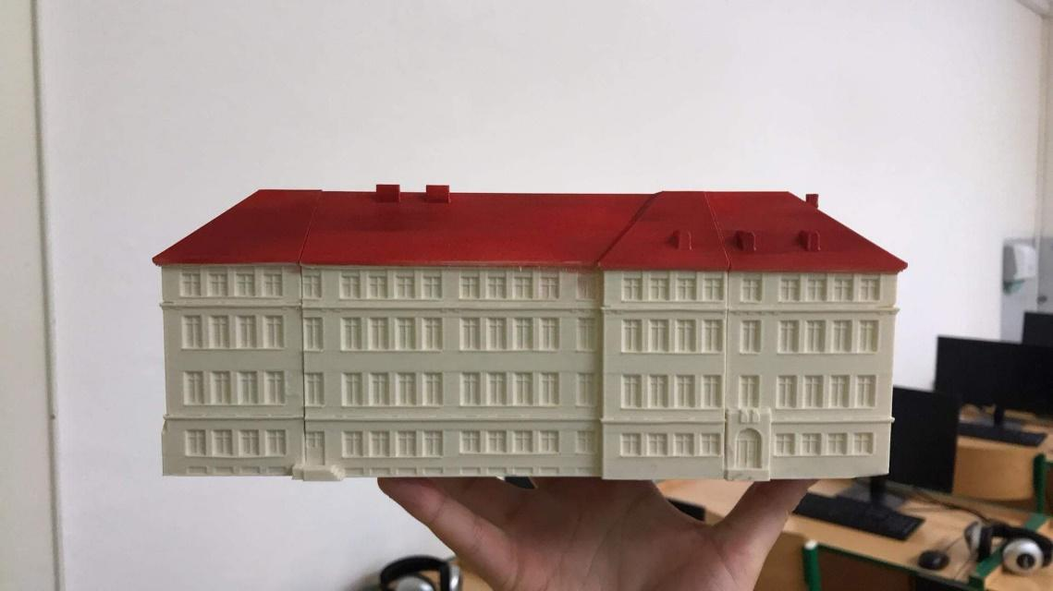

3D printer problems
When printing on a 3D printer, we gradually encountered problems that we had to solve during the printing process.
For example, with frequent printing, the pad became out of balance over time and the print was spoiled from the start. Calibrating the pad consisted in tightening or loosening the outer wheels so that the pad reached an equilibrium position.
After recalibrating it, we also had to set the correct height of the header above the pad in the 3D printer in order to print the first layer correctly. Using the "Babystep Z" function directly in the printer menu, we tried to adjust the size of the header, and then printed the first layer every time until we got the print right.
Another problem was surface adhesion (adhesion), which worsened over time and the first extruded layer of filament did not adhere well to the substrate. We solved this issue by cleaning the pad with a cloth and alcohol spray. Then we applied a layer of adhesive glue and the problem was solved.

Photo

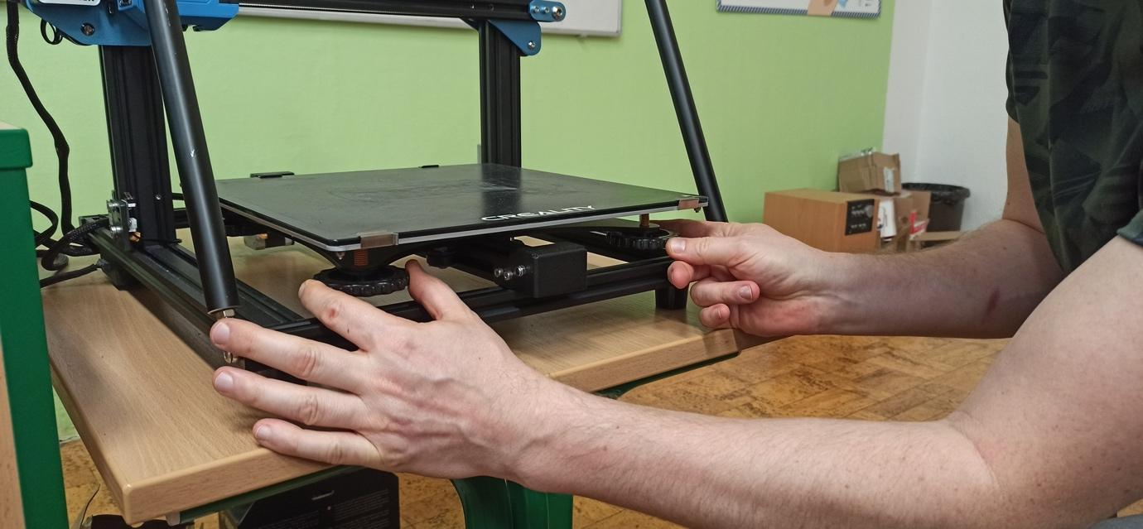

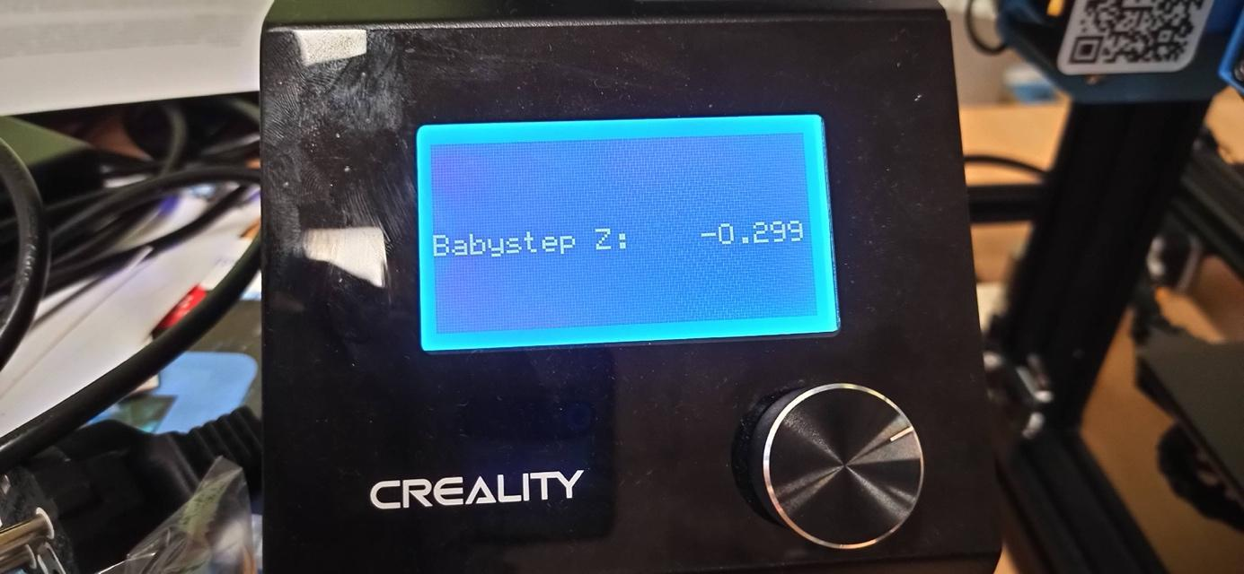

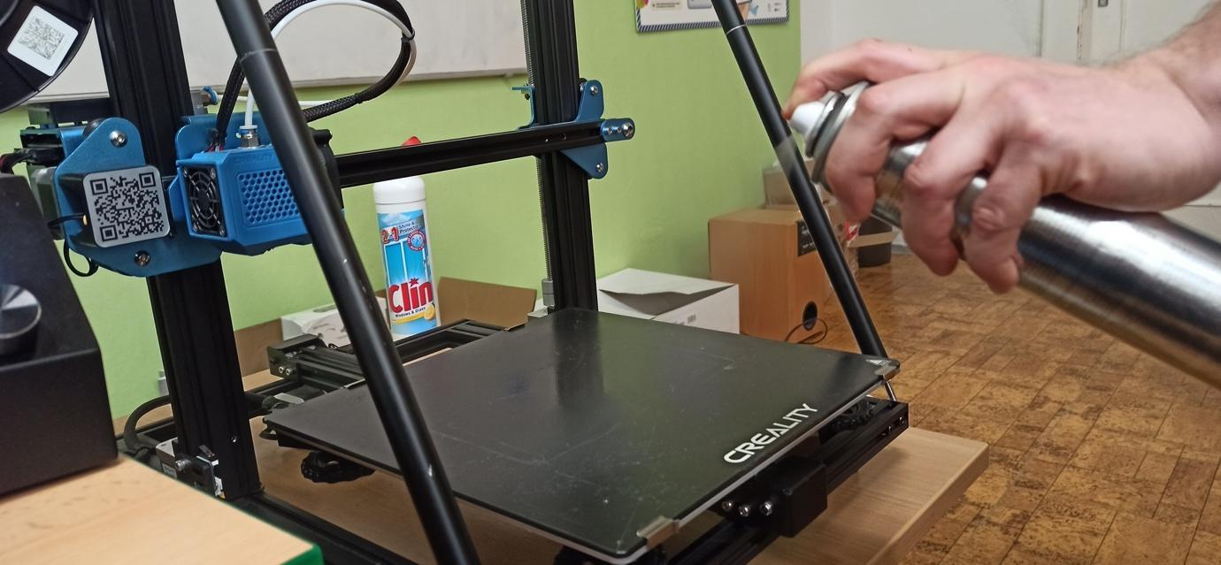

Conclusion and contribution of the project

- Creation of the most plausible digital object of the school model in the graphic program sketchup.
- A printed model of the school on a 3D printer used for the presentation of the school.
- Acquiring and increasing the digital competences of students and teachers with new equipment and with new technologies that were not available at our school until now.
- Solving problems through digital technologies – students and teachers get to know modern technology, solve problems on the way to the goal, propose different solutions, carry out a procedure and evaluate the success of the progress towards the goal.
- The possibility to continue working in the graphics program sketchup and with a 3D printer on other projects in the subjects of Computer Science and the World of Work.

